Meet our Volunteer Exhibitions Panel – for the Community Spotlight Case!
Supporting community exhibitions in Charnwood Museum

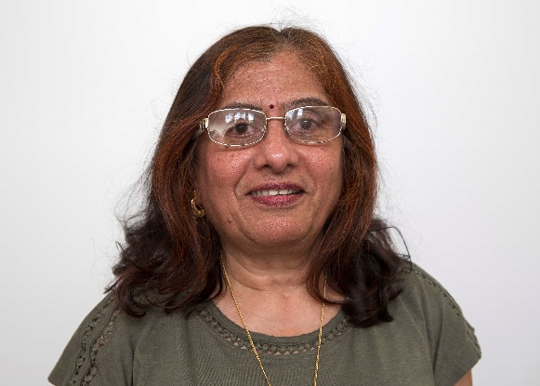 | Meet Anila…  Hi, my name is Anila. I am the co-ordinator of the Anand Mangal Ladies group who regularly meet at Fearon Hall in Loughborough. I love living in Charnwood, it is truly my home. I am passionate about encouraging communities to use this exhibition space because I was supported to do this myself. I was able to share my memories of forced migration from Uganda and the achievements of my community and separately my Indian and Hindu faith and culture using textiles as inspiration. I want to encourage people to use this opportunity to share their passions, skills, history, and culture so that we can all learn from one another and understand each other better. At first, it may seem like a mountain to climb but when you get to the top it’s exhilarating.
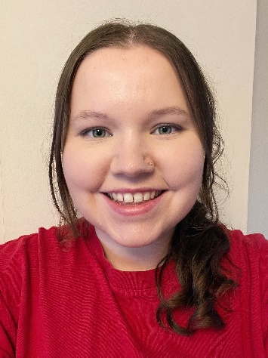 | Meet Lauren…  Hi, my name is Lauren. My volunteering role is within the Community Exhibition Panel. I have grown up living in the Charnwood area and have subsequently returned to live and work within the area after graduating from university. Throughout University I was able to collaborate with my coursemates and showcase our work through exhibitions, and the joy you experience seeing what you have created come to life is something I hope I help others to experience whilst being a part of the Panel. Heritage and culture excite me as they are at the very heart of our identity and values. Charnwood itself is bursting with diversity that is waiting to be explored, shared, and documented. I am passionate about collaborating with others to ensure the story of Charnwood will be shared and I aim to actively participate in celebrating and connecting people through their heritage and culture.

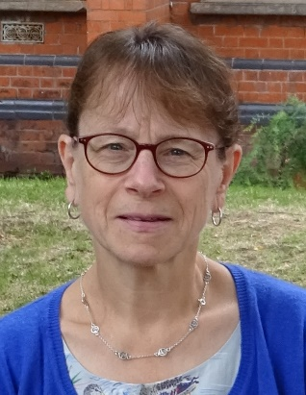 | Meet Lynne…  Hi! I’m Lynne, an early-retired librarian, and now an author, walker, talker, and blogger. I’ve lived in Loughborough since 1978, when I arrived as a student at the university, and I’m keen to promote Loughborough whenever I can, wherever I can, and to everyone I can! I love visiting our museums and museums elsewhere; taking part in heritage events; writing; singing, and walking in Loughborough, and the surrounding areas. I want to help people share their memories and love for Loughborough too: Charnwood Museum is a popular attraction, so the Community Spotlight Case is an ideal place to do this. Let’s share our heritage and culture widely so we can better understand and appreciate each other.
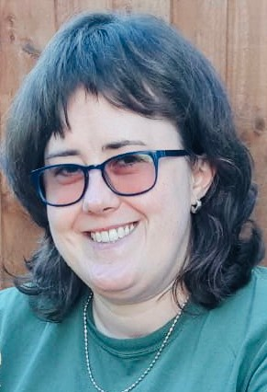 | Meet Esme…  Hello! My name is Esme and I am passionate about local history and heritage after volunteering as a Community Curator back in 2020 and being supported by the Participation Team to create my own Sooty exhibition! As a child, Sooty empowered me to connect with the world around me, which was more challenging because I had undiagnosed Asperger’s. Sooty helped me to learn everything from math to ABCs, and even say my first word, ‘Ooty’. I want to encourage others to be brave enough to share their special stories and have their voices heard in the museum. I think it is exciting being able to discover something new about people’s culture and what’s important to them. I was so proud of what I achieved, I gained lots of new skills along the way and had so much fun too – you’ve got nothing to lose!

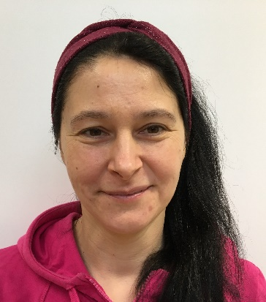 | Meet Jola…  Hello! My name is Jolanta, and I am a proud Polish woman living in Loughborough. I work as a Nursery Assistant and an Art Coordinator at my church. I have a master’s degree in Museology and my studies have led me to live in several different countries. I love art and history and I’m passionate about museums and highlighting important issues. My favourite thing about being part of the Charnwood Community Curators Exhibition at Charnwood Museum in November 2020 was being given the opportunity to introduce and help people to engage in Polish culture. I think it is important to find creative ways to encourage more understanding of our cultural differences and give people a platform to showcase their ideas and personal heritage. As a panel member, I look forward to hearing new stories and supporting more members of the local community along their exhibition journey!
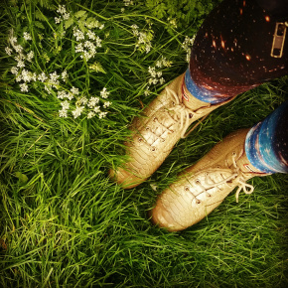 | Meet Emily…  Hi, I’m Emily and a volunteer panel member for the Charnwood Community Spotlight Case. I love storytelling in all its forms, and I have always loved writing – an interest developed after editing Loughborough University student newspaper when I studied there. I’m passionate about creating disability-inclusive, intersectionally aware cultural activities. I have worked in SciComm, the practice of informing, educating, and raising awareness of science-related topics for several years and I enjoy organising events that enable me to facilitate this interest. I love the arts in general with a particular focus on community wellbeing, nature engagement, and sustainable activities such as recycled crafting. I am a local resident in Charnwood and want to use my experience and skills to help local community groups share information about themselves and tell their stories in their local museum.

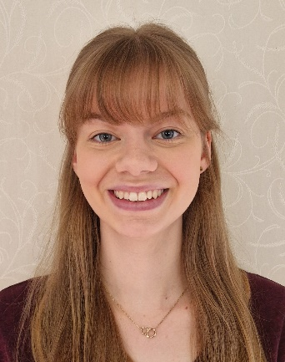 | Meet Sarah…  Hi I’m Sarah. Growing up in Charnwood has given me an insight into what this wonderful borough has to offer people of all ages. Some of my fondest memories as a child are exploring the local countryside and museums with my family. Now, I’m proud to share this heritage with friends I made at university when they visit me in Loughborough. My childhood memories of Charnwood’s heritage were a key part in my decision to study History and Archaeology at university. I love how heritage connects us to our past and the world around us today – it is a part of all our experiences! By being part of this panel, I hope we can show that heritage is so varied and for everyone. Charnwood’s heritage is created by all of us and I hope to help share this rich variety with our community.
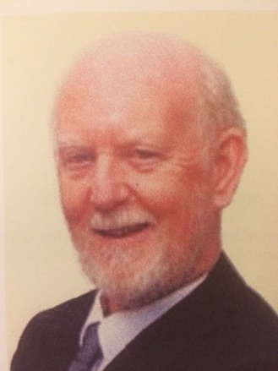 | Meet Martin…  Hello. Being both old and male I have been invited onto the Panel to give some balance in these respects. I came from the North East to Loughborough during the war, went to LGS and studied Engineering at the College in Dr. Schofield's day, so have lived through some Charnwood history! I married a Loughborough girl, strengthening my local ties, and three of my four daughters live in town. Both as a lecturer at Loughborough College and as a member of the local Baptist church I have been involved in publicity, displays, and exhibitions. It is a privilege to reside in Charnwood, to enjoy its countryside and history, and to live in its diverse community. I hope that together we can make its benefits better known and appreciated.

